How To Order GHS SA Gambling Harm Minimisation items from Winc.com.au

This guide was developed for anyone to learn the process for logging into your Winc account, searching for specific products, and finalizing your order for shipping. This guide covers everything from searching for items, managing your cart, handling delivery details and tracking items.

Contents
Logging into the system 2
Selecting an item 3
How to search for an item 6
How to quick add items 9
Reviewing your cart 10
Completing your order 11
How to track your order 17
Logging out of the system 20
Items not in stock 21
Item stock limit 22

For any issues, please contact the Sharee Aldridge at Sharee.Aldridge@winc.com.au or the Gambling Harm Support SA team at gamblingharmsupport@sa.gov.au

 | 

Logging into the system
Navigate to https://www.winc.com.au/
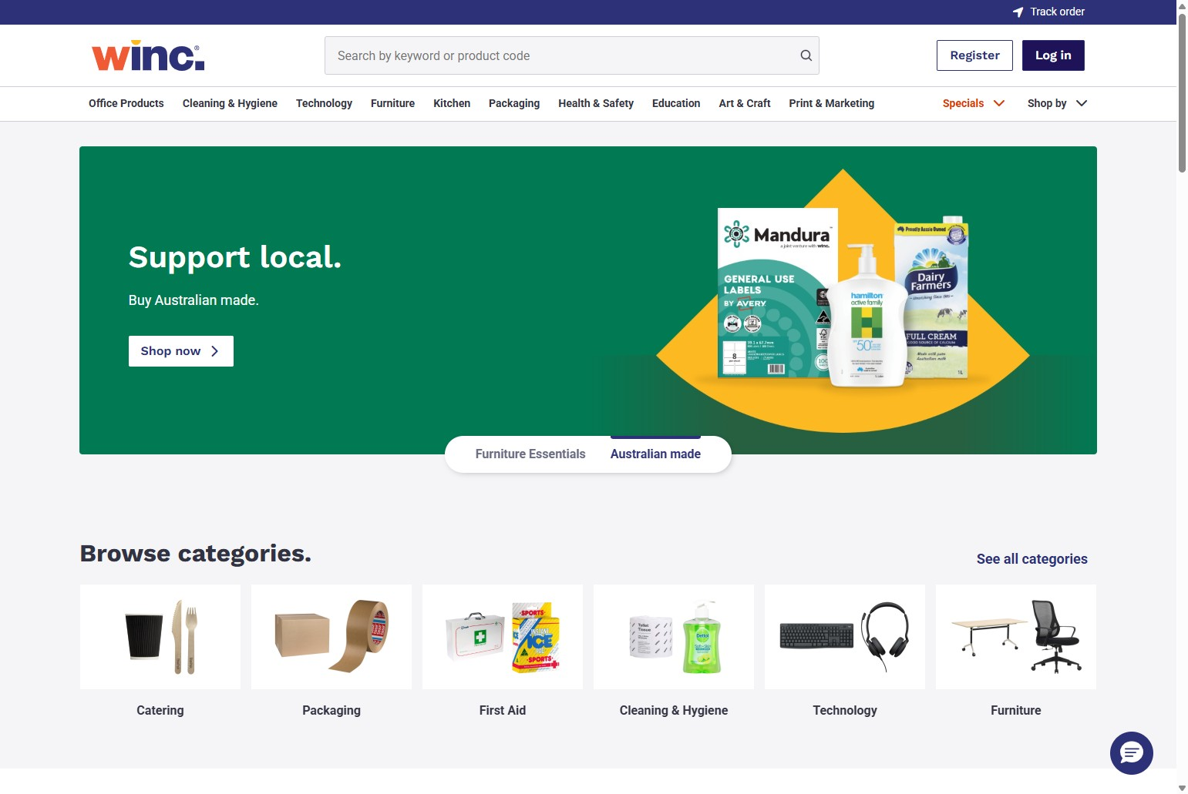
Click ‘Log In’

Enter your log on details and click "Log in"
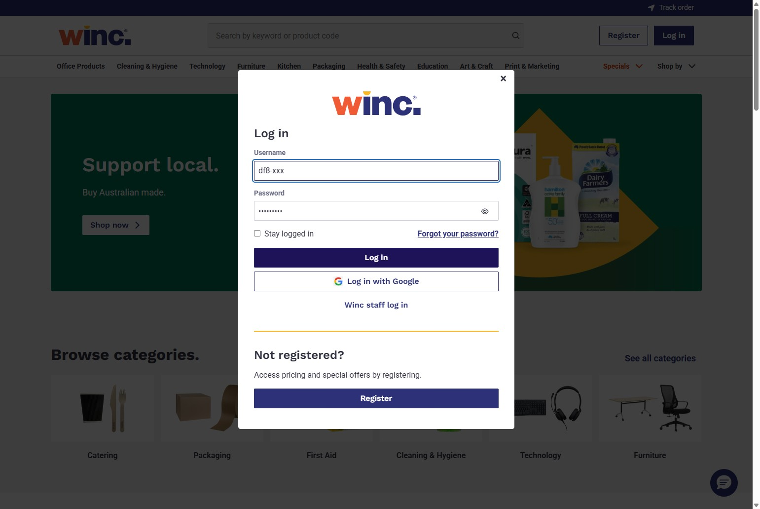

Selecting an item
Click the item you want to order from the home screen
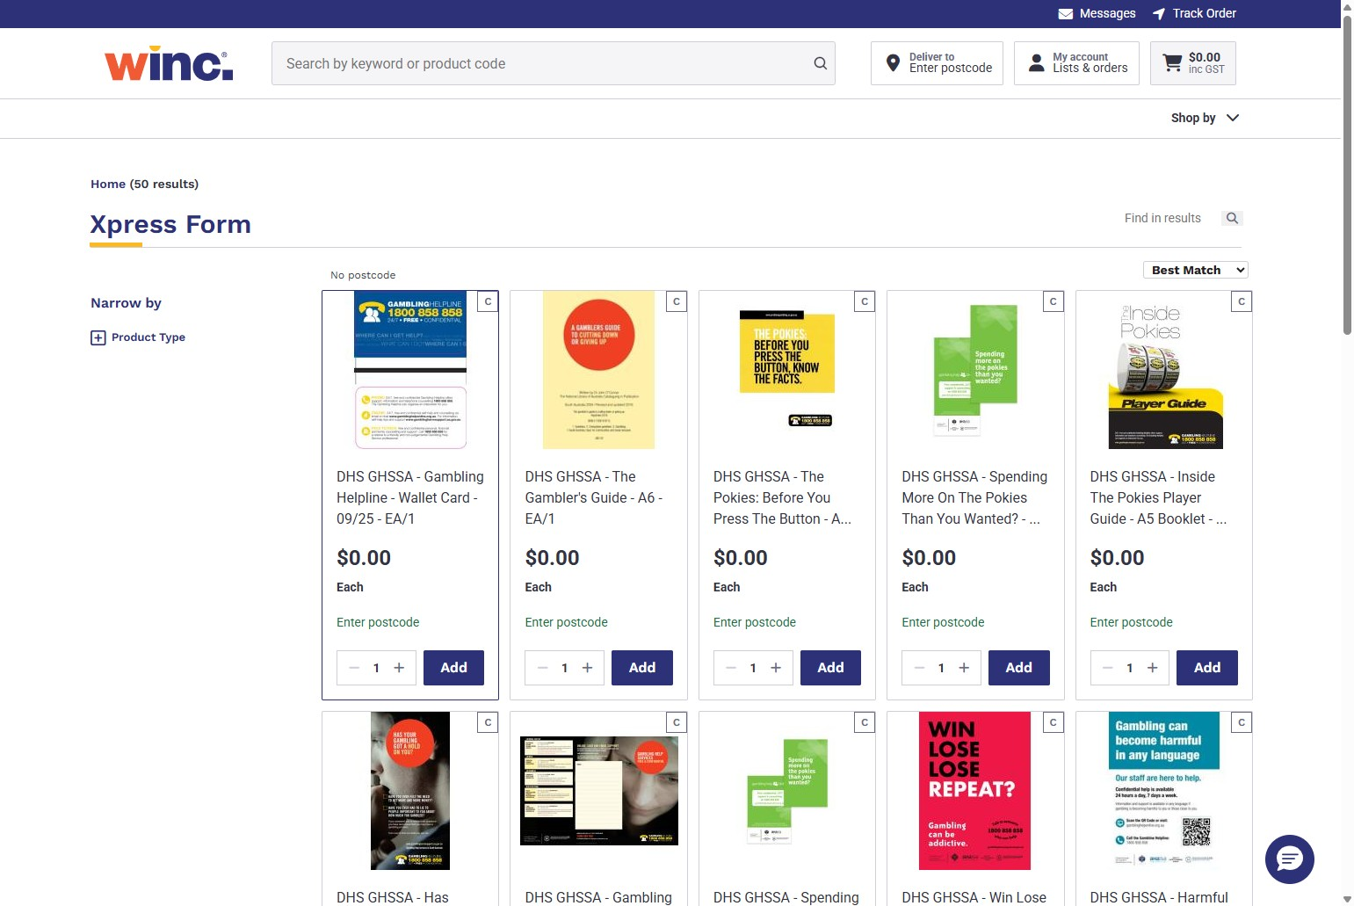
Enter the amount you want to order.
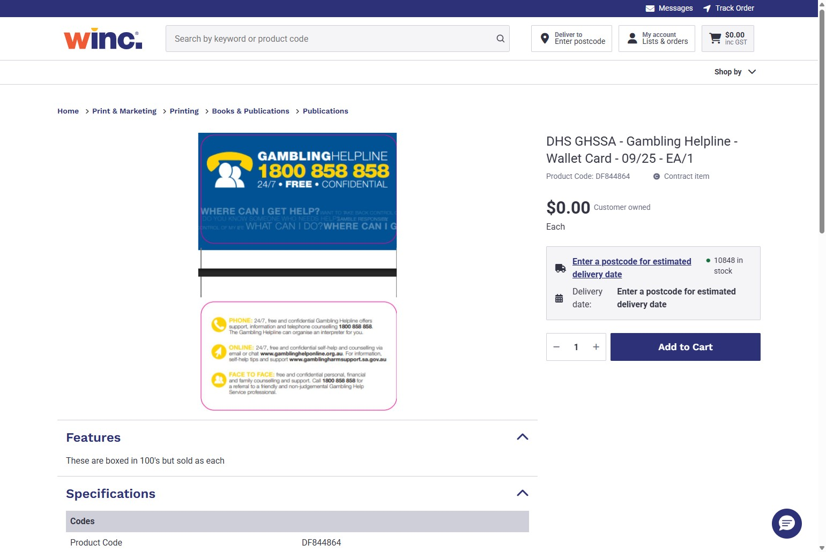

Click "Add to Cart". Note: stock quantities are now visible on available items
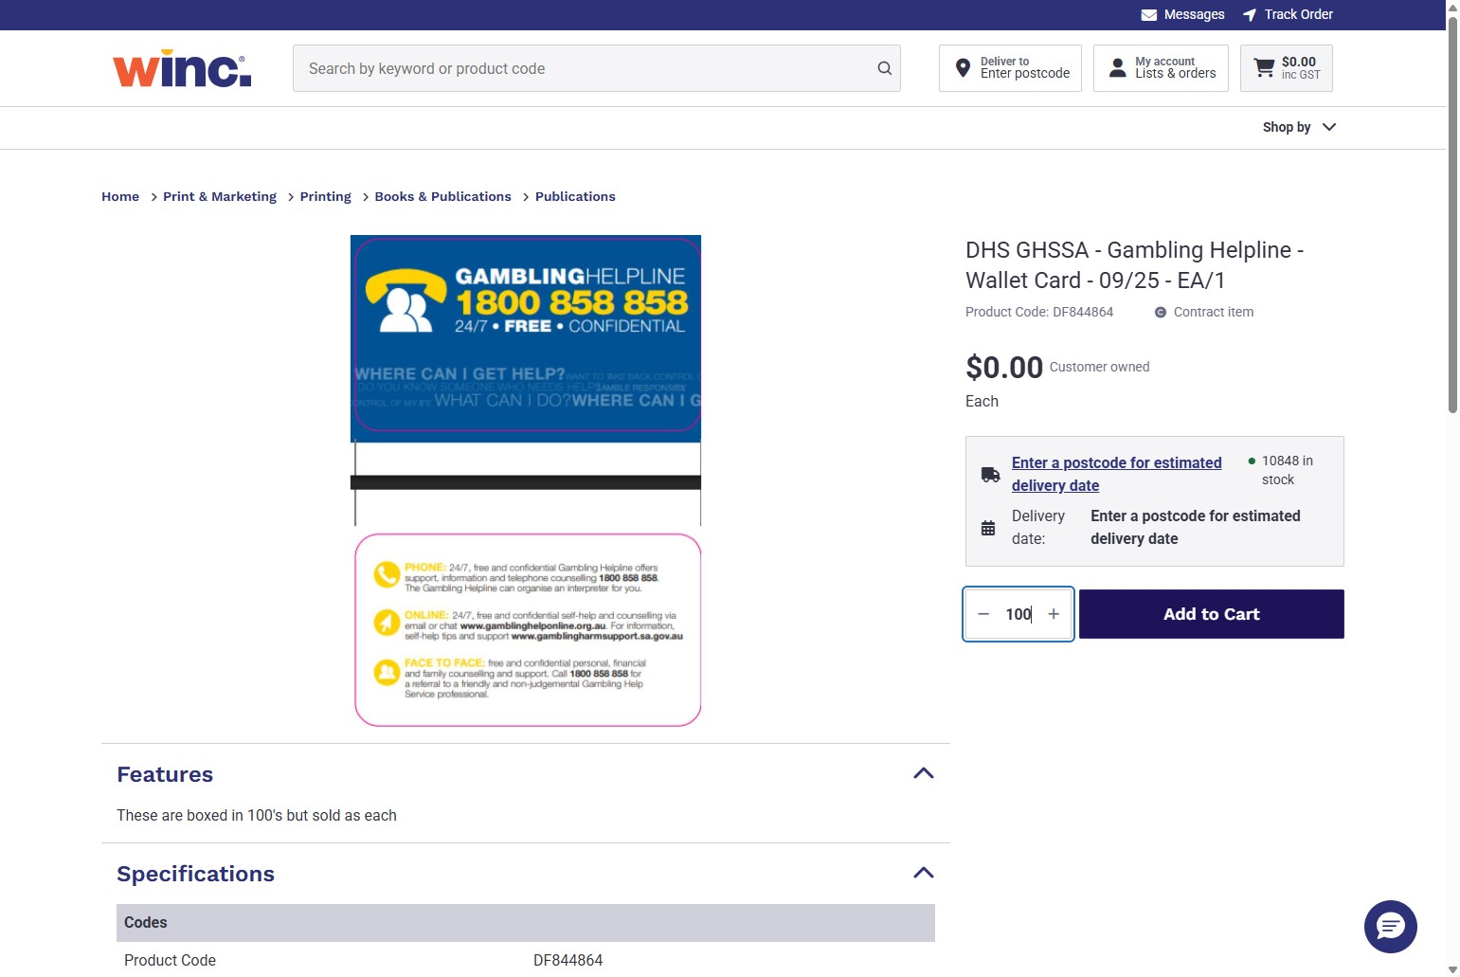

Click "View Cart" to see your cart or "Continue Shopping" to order more
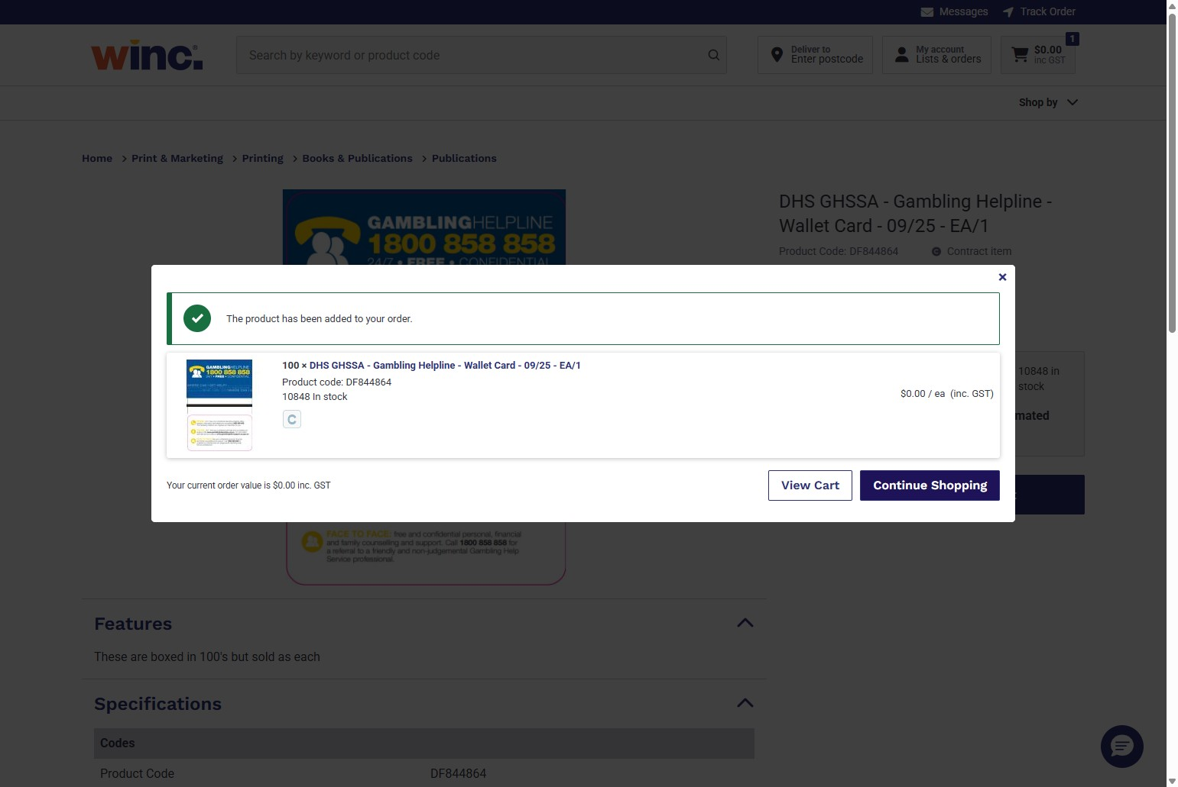

Click "Home" to go back and order more items
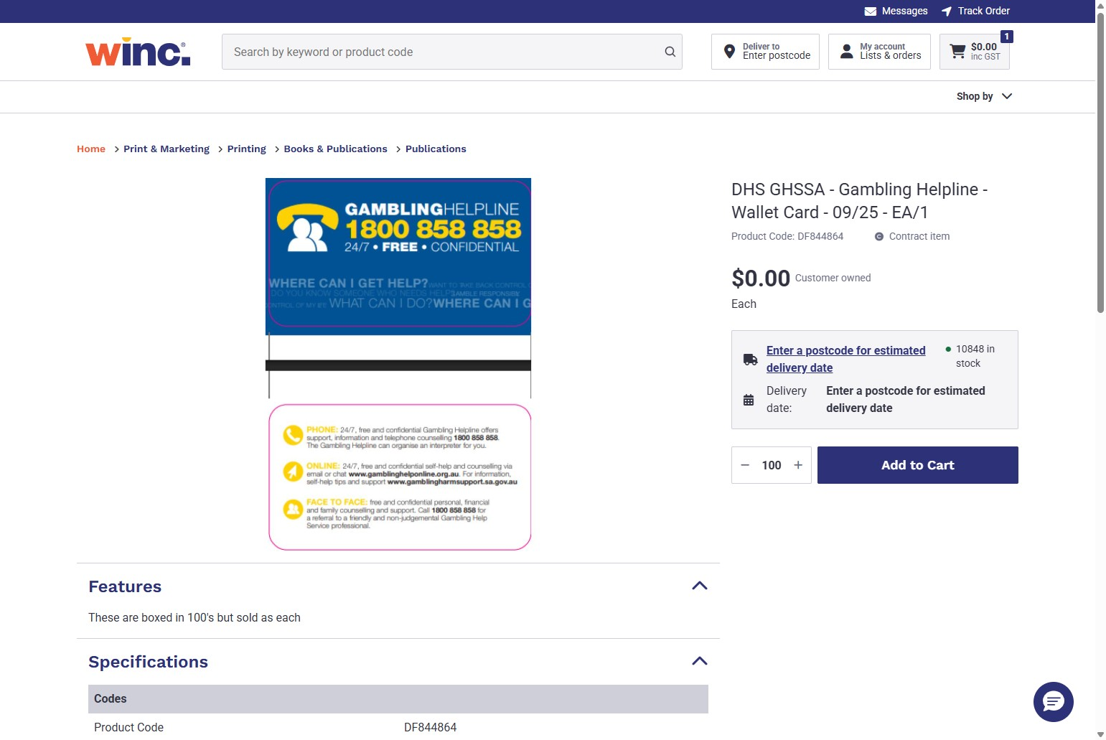

How to search for an item
Click the "Search by keyword or product code" field & enter the item name or code
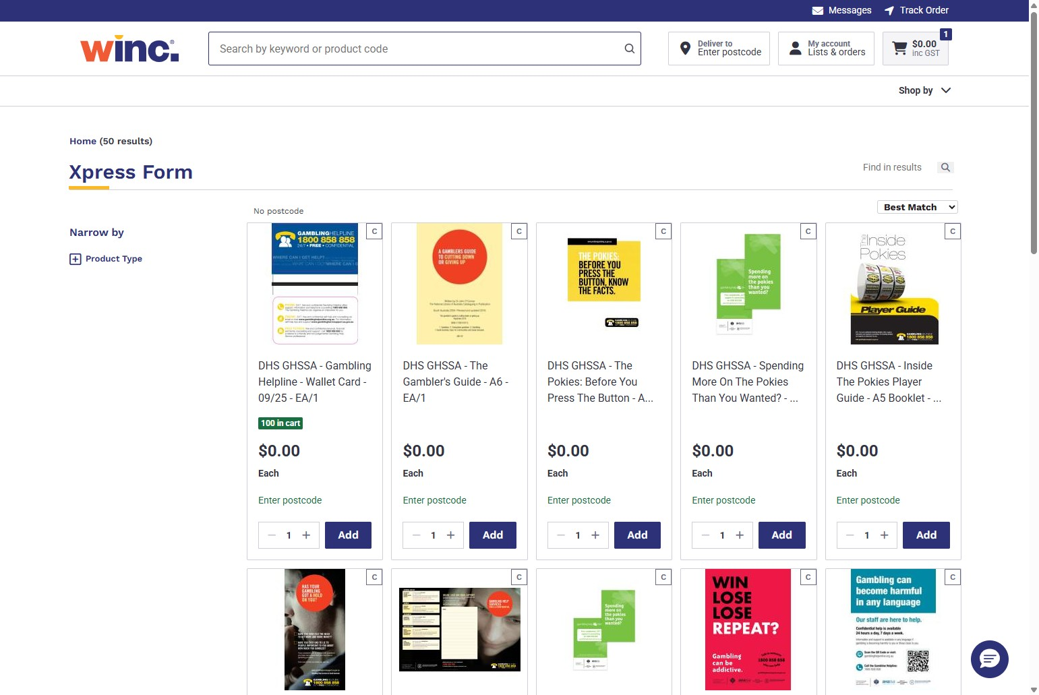

If the item exists, it will appear in the result field, click to view it
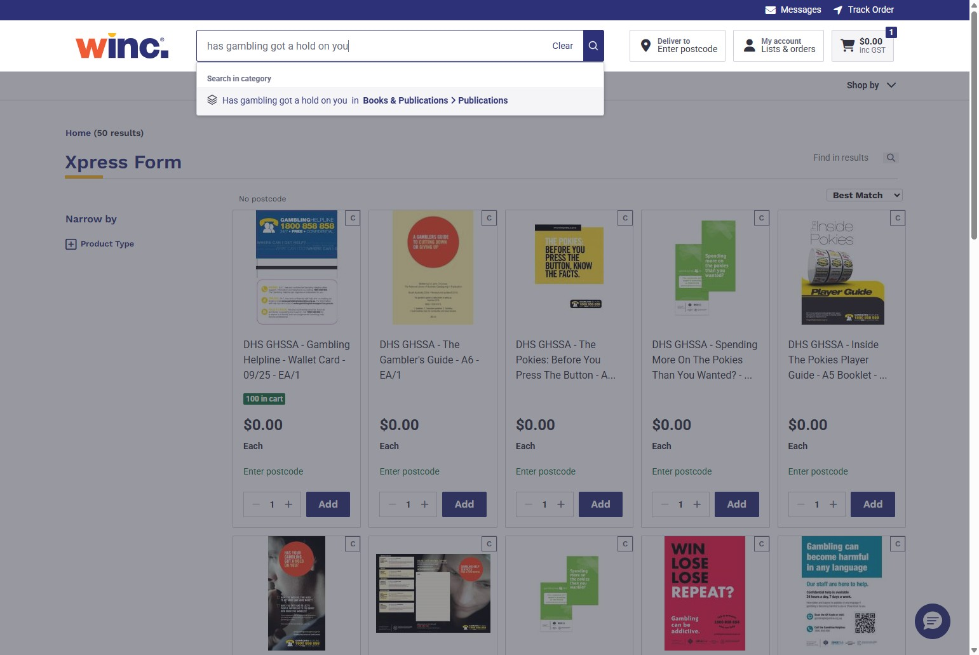
Click on the item
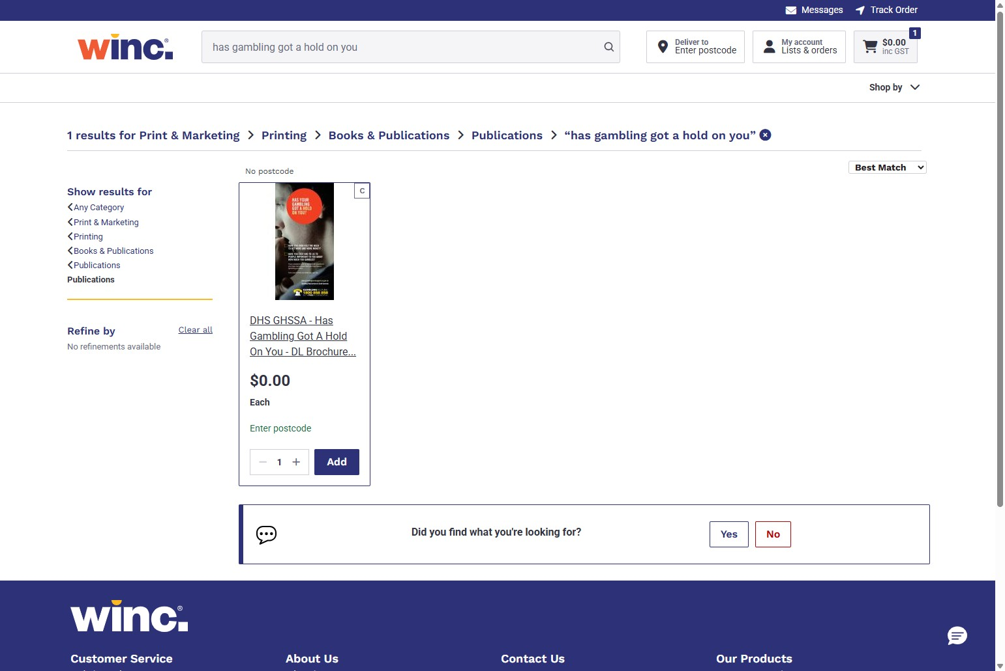

Enter your order amount
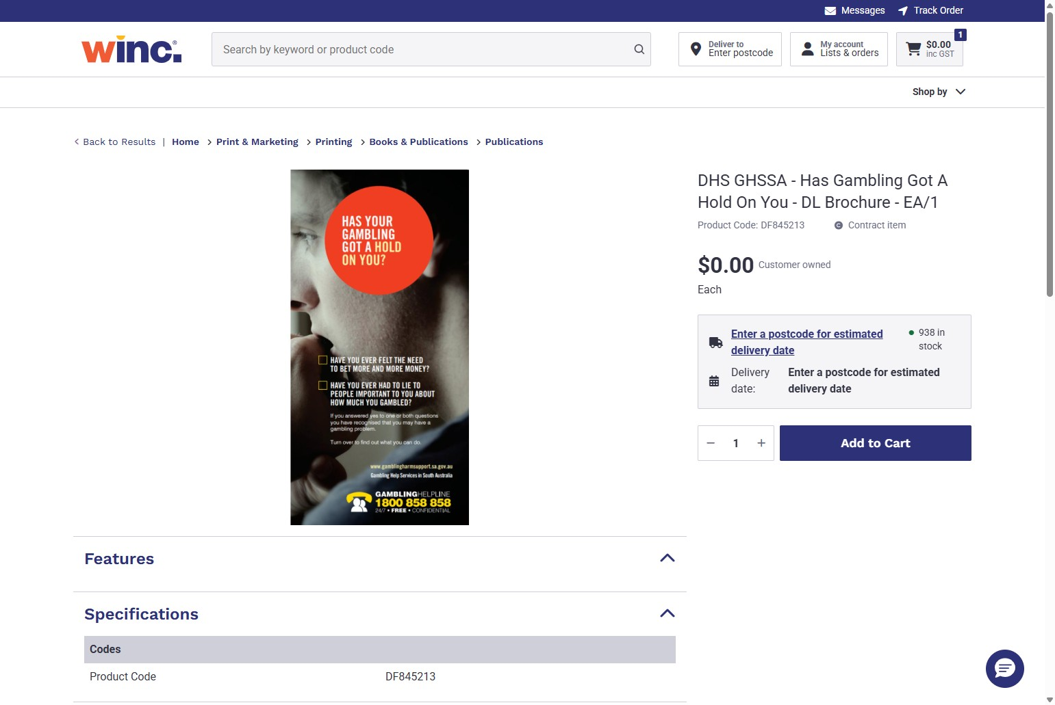

Click ‘Add to Cart’
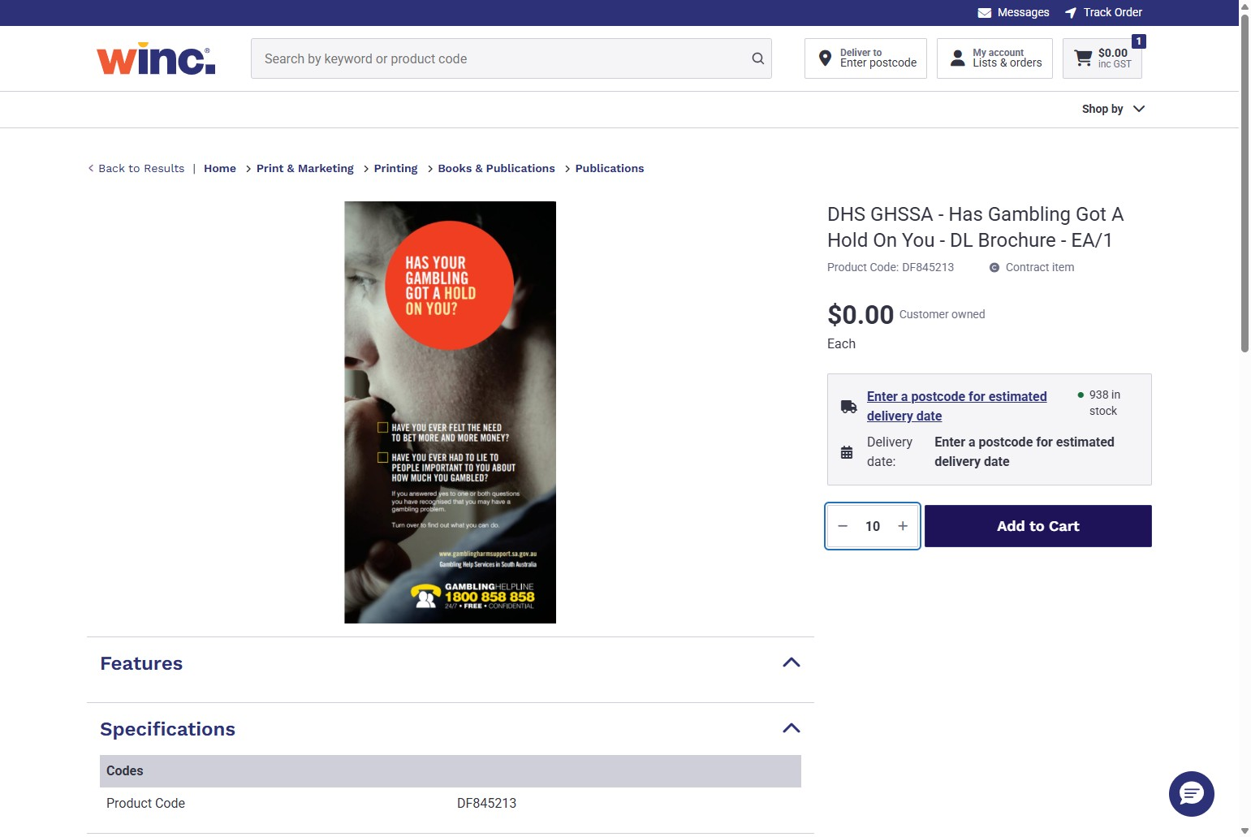

Click "Continue Shopping"
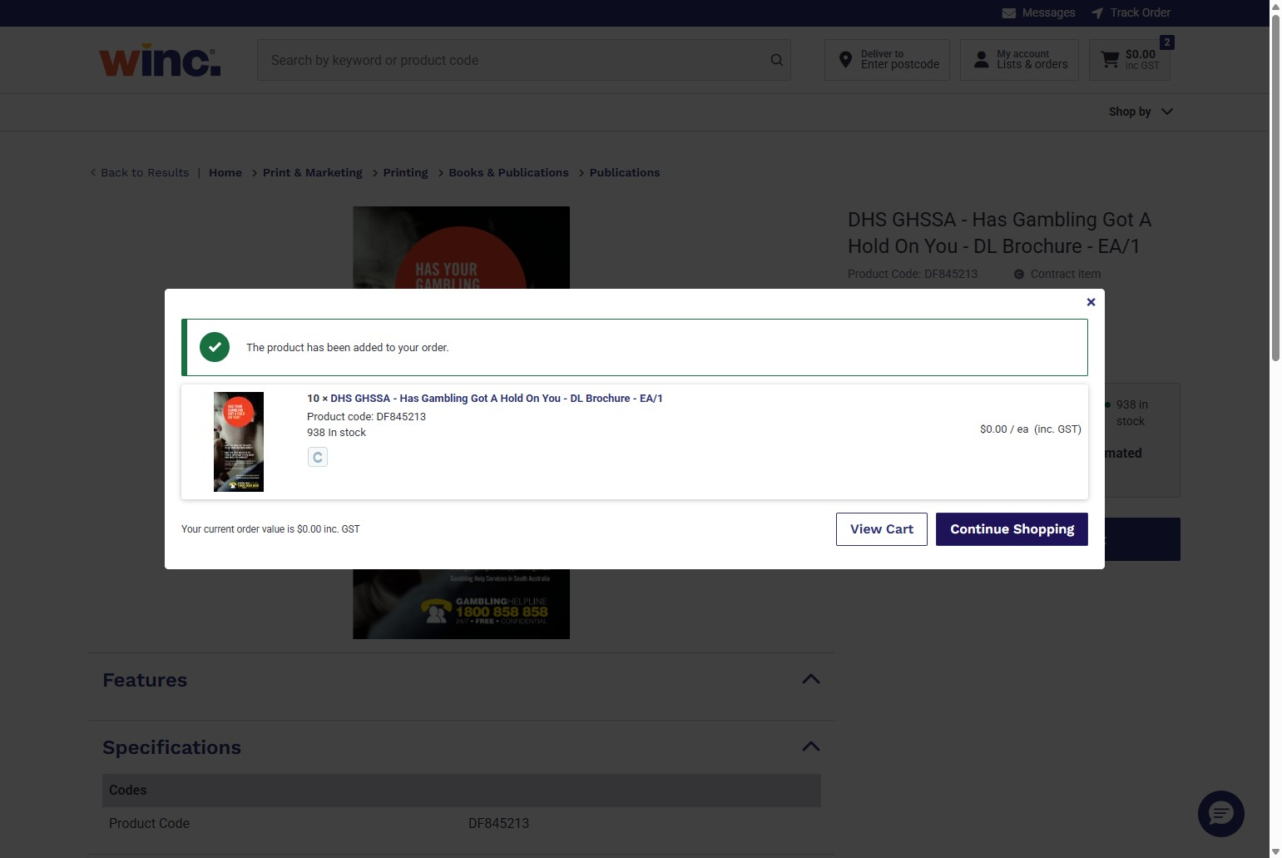

Click ‘Home’ to return to the homepage and order more items
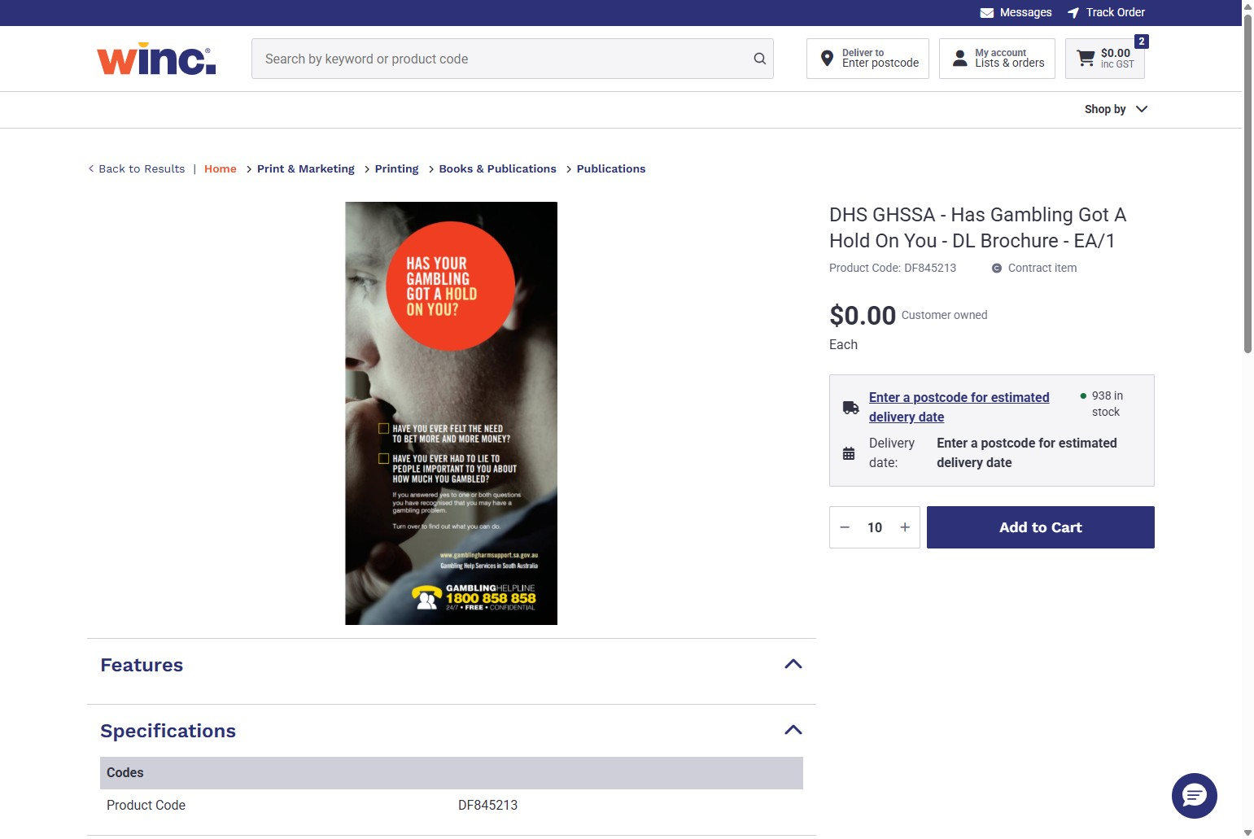

How to quick add items
To add items quickly to your cart from the home page, click "Add" (if you only require 1) or select the amount you need and then click "Add"
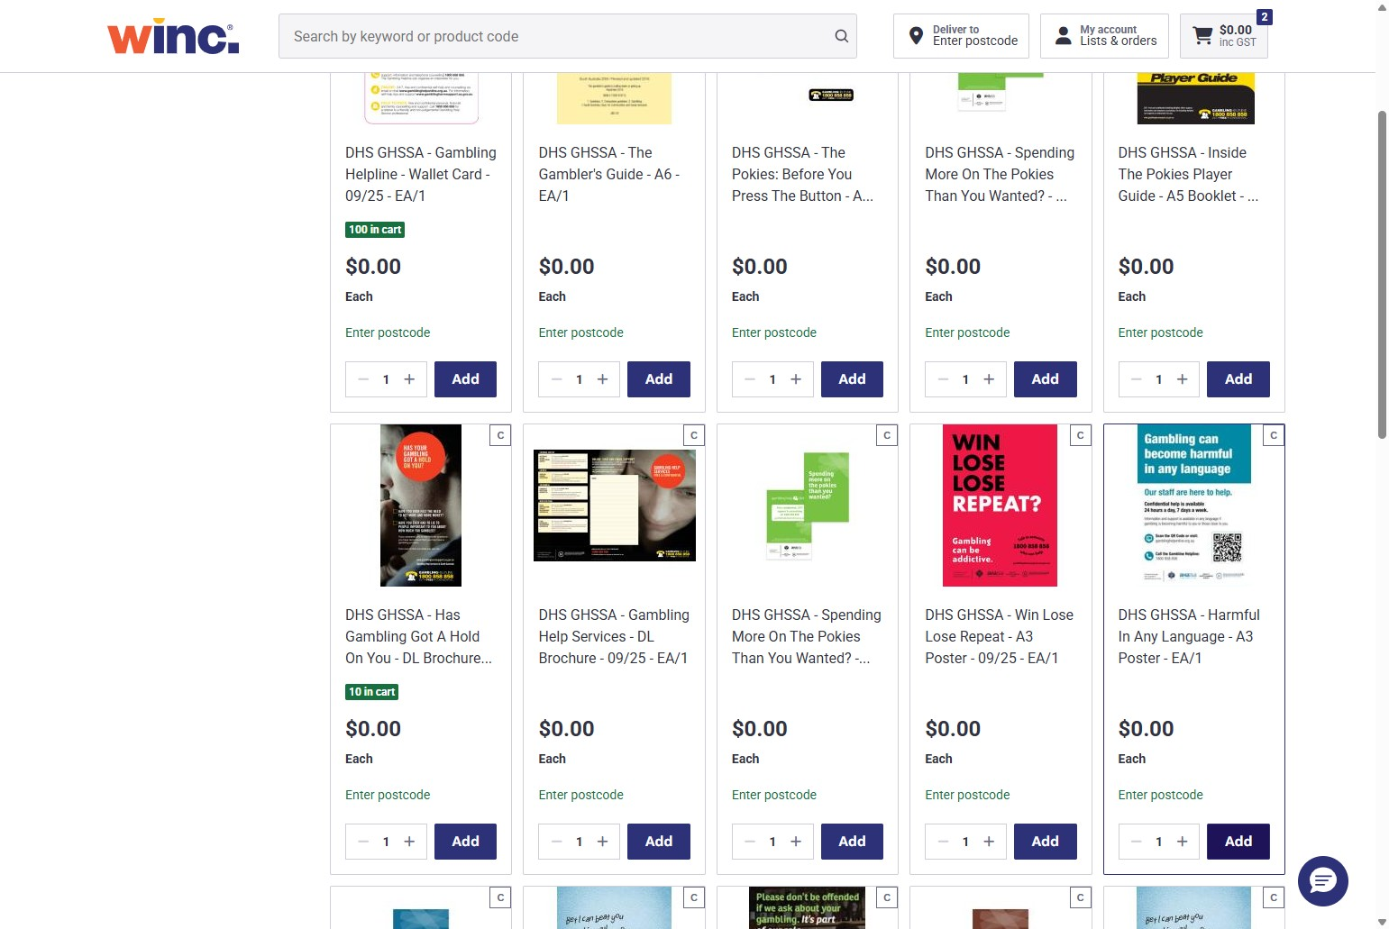
If you are ready to complete your order, click "View Cart"
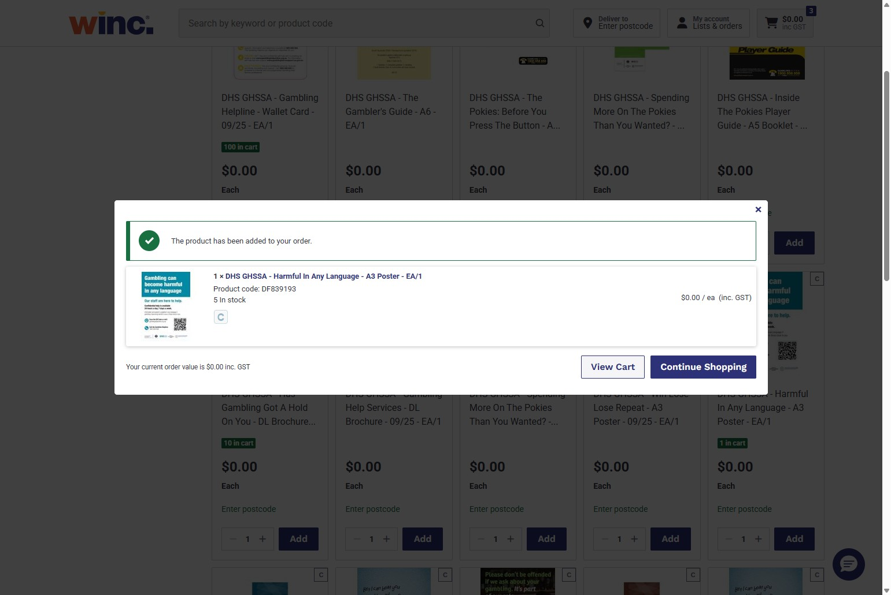

Reviewing your cart
Click "Review cart" to begin finalising your order
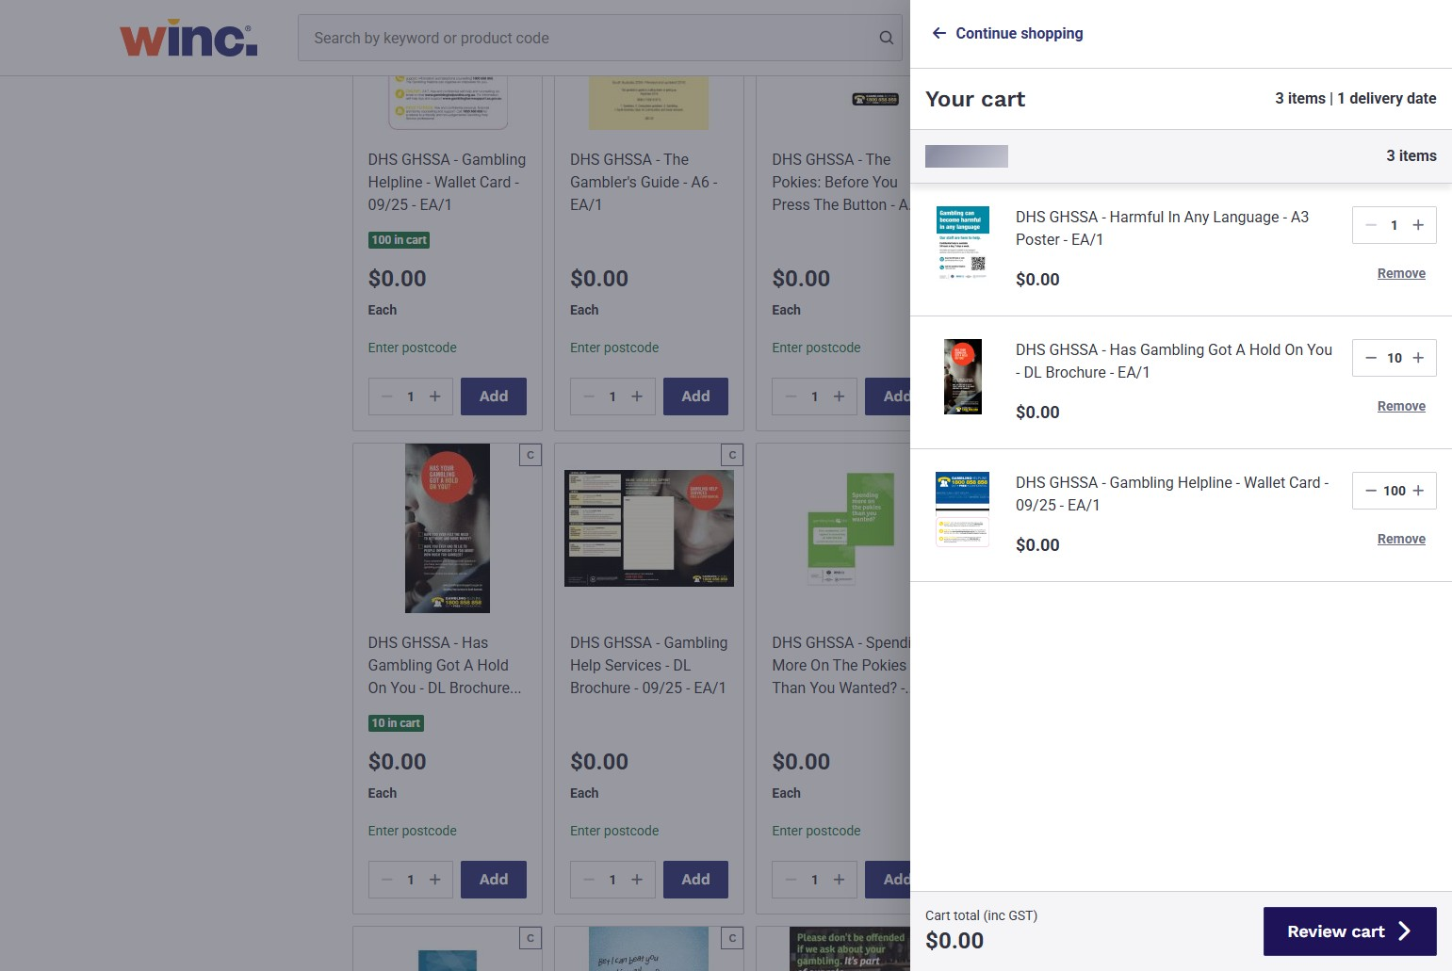
After reviewing your cart, click "Continue to Checkout" to proceed
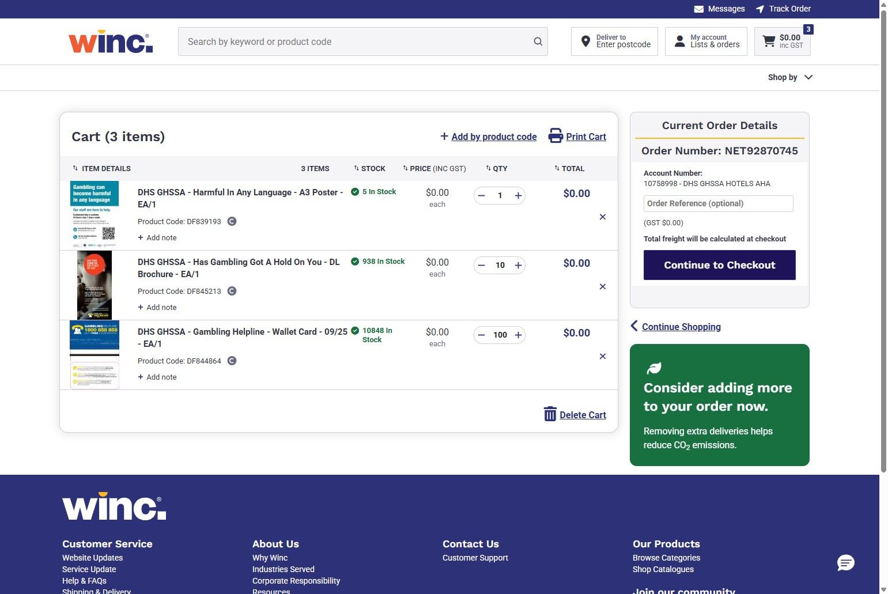

Completing your order
Step 1: Contact Information. Enter your details (Name, Email & Mobile/Telephone)
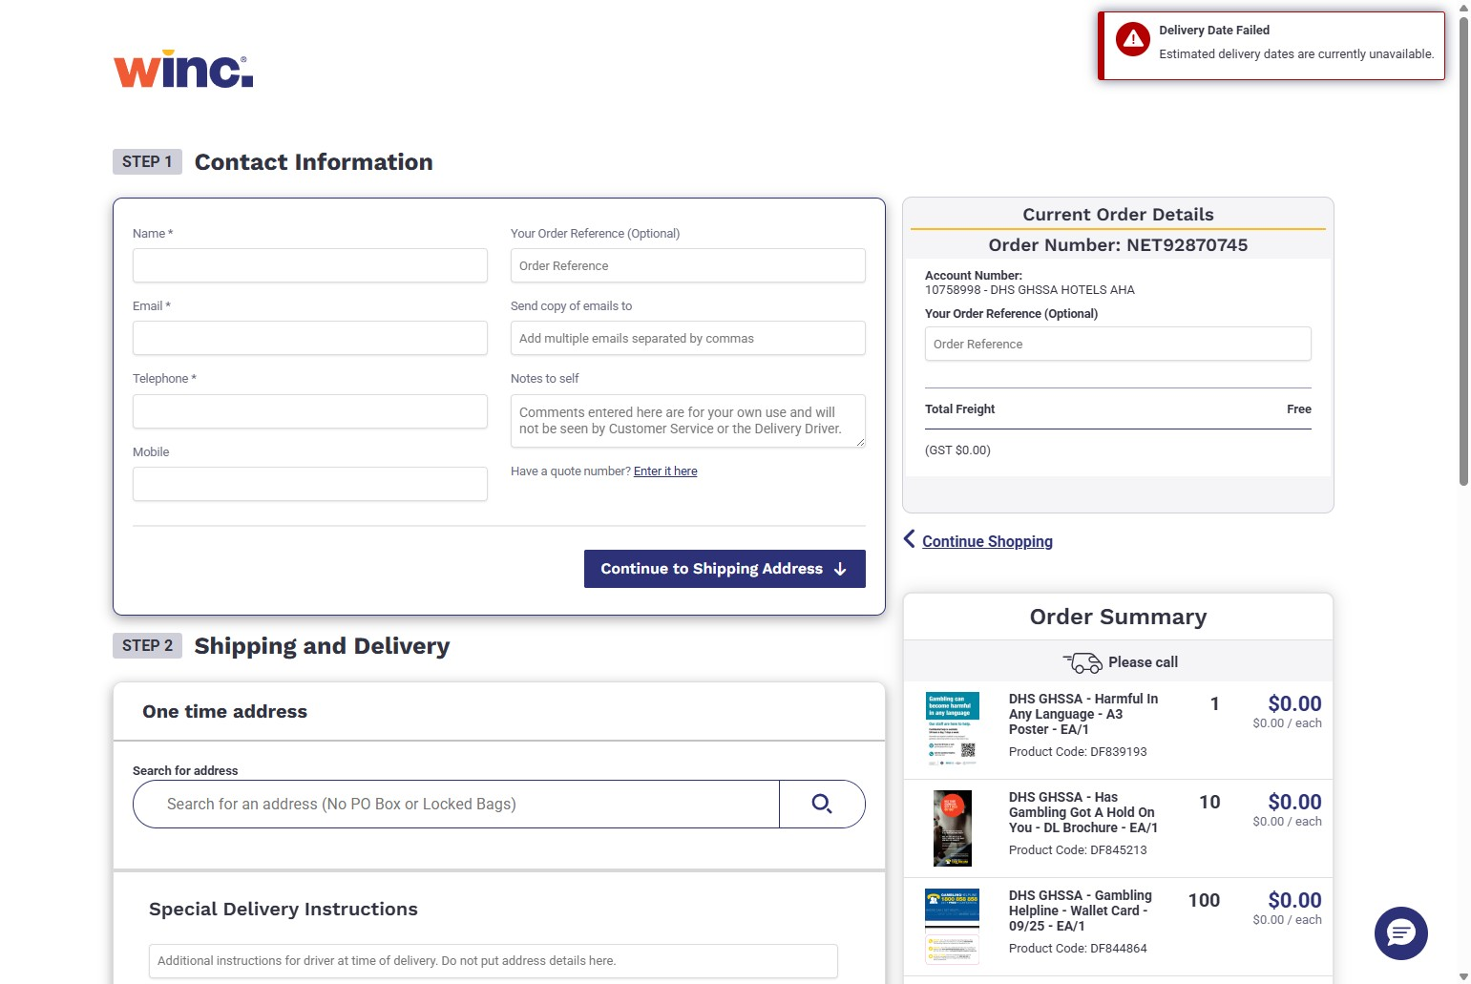
Once completed, click "Continue to Shipping Address"
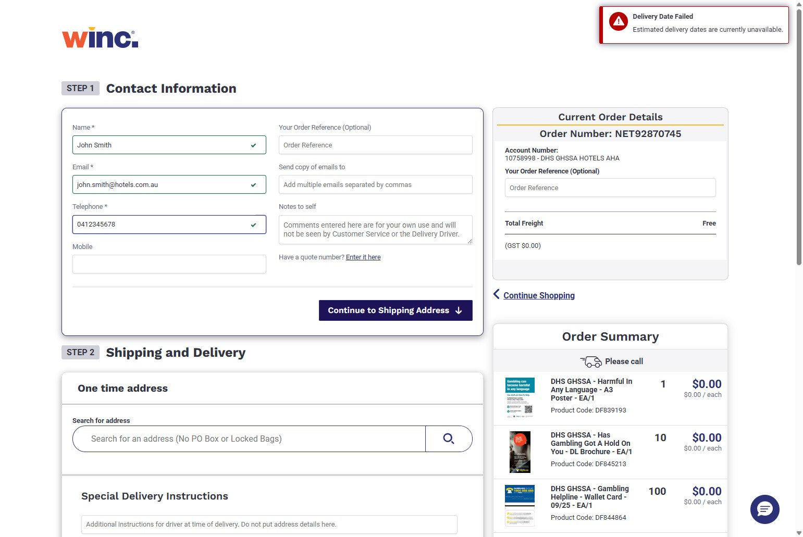

Step 2: Shipping and Delivery. Click the "Search for an address" field
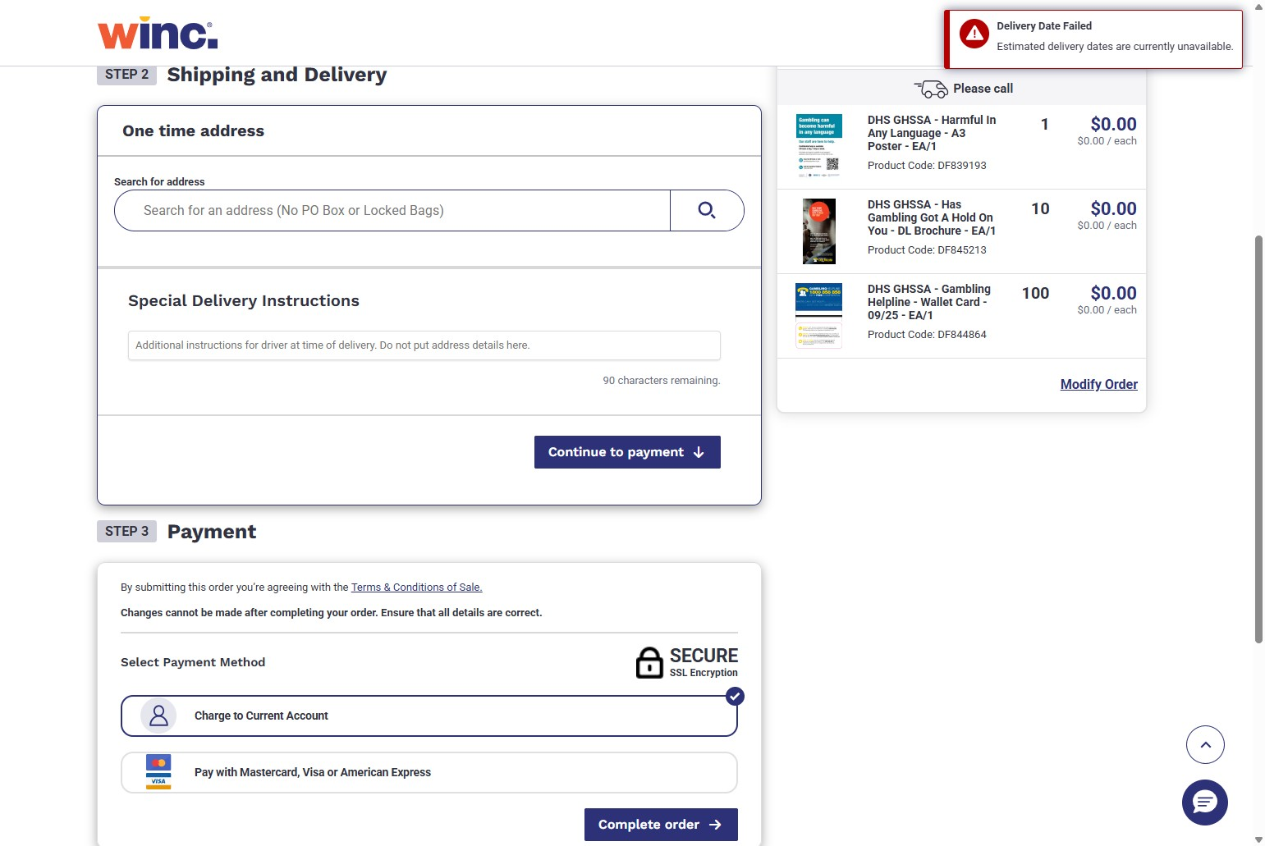

Search for your address. Once found, click your address from the search results
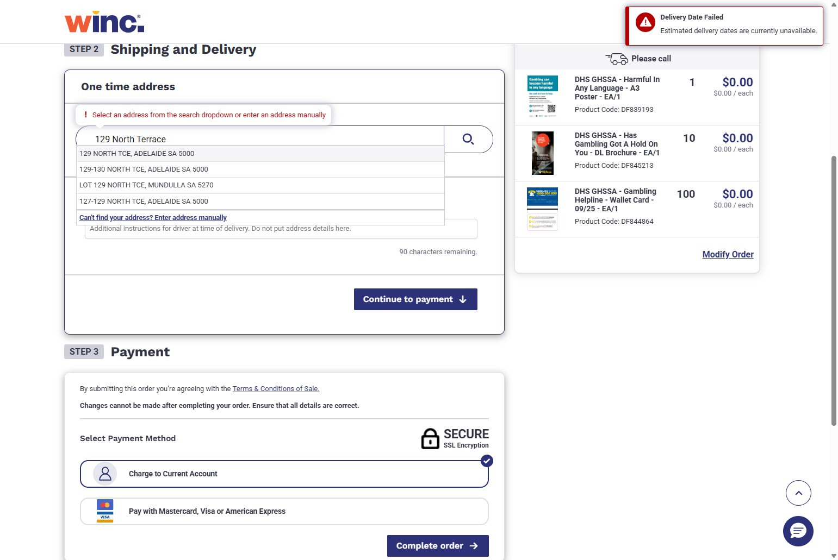

If you make a mistake, you can click "Clear address" to remove it
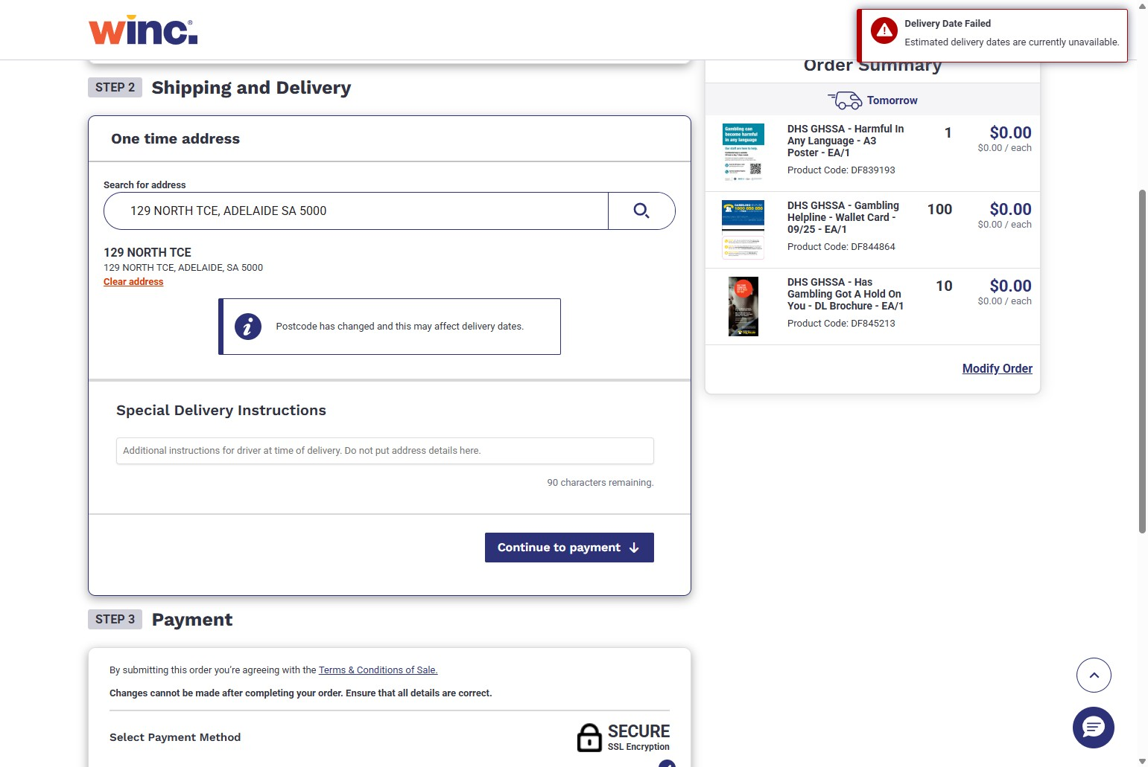

If you want to enter your address manually, click the "Can't find your address? Enter address manually" option when searching
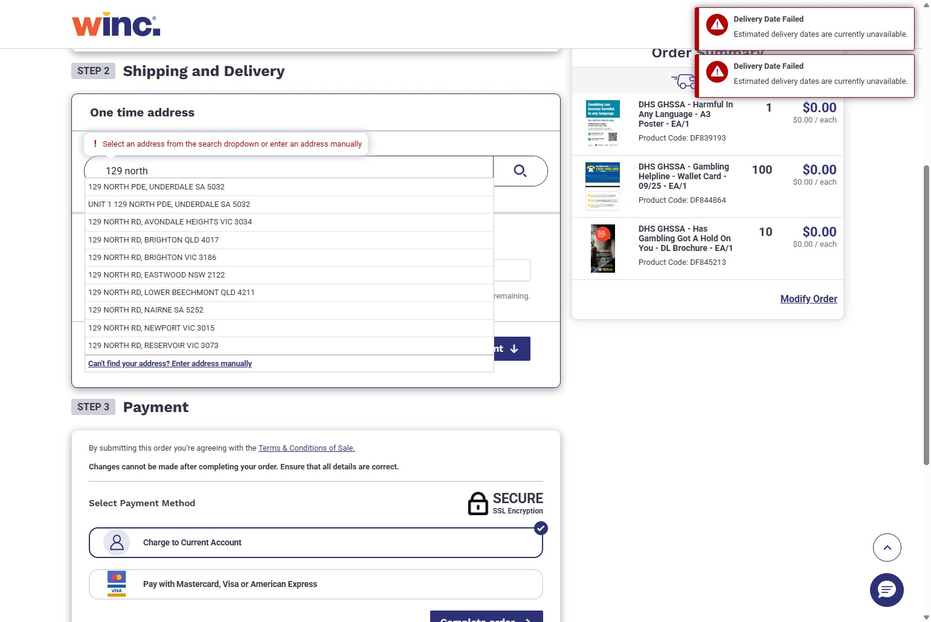

Enter your full address details in the required fields
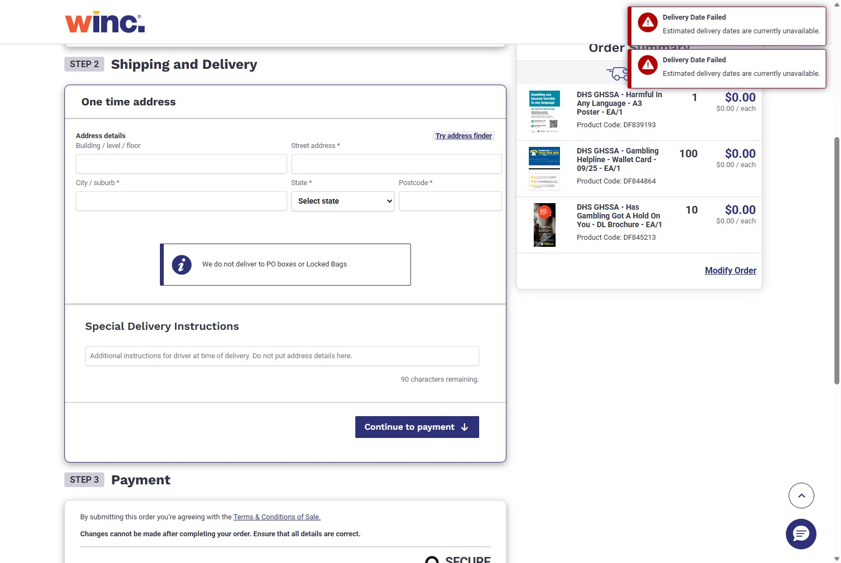
You can leave special delivery instructions such as specific places, people or roles
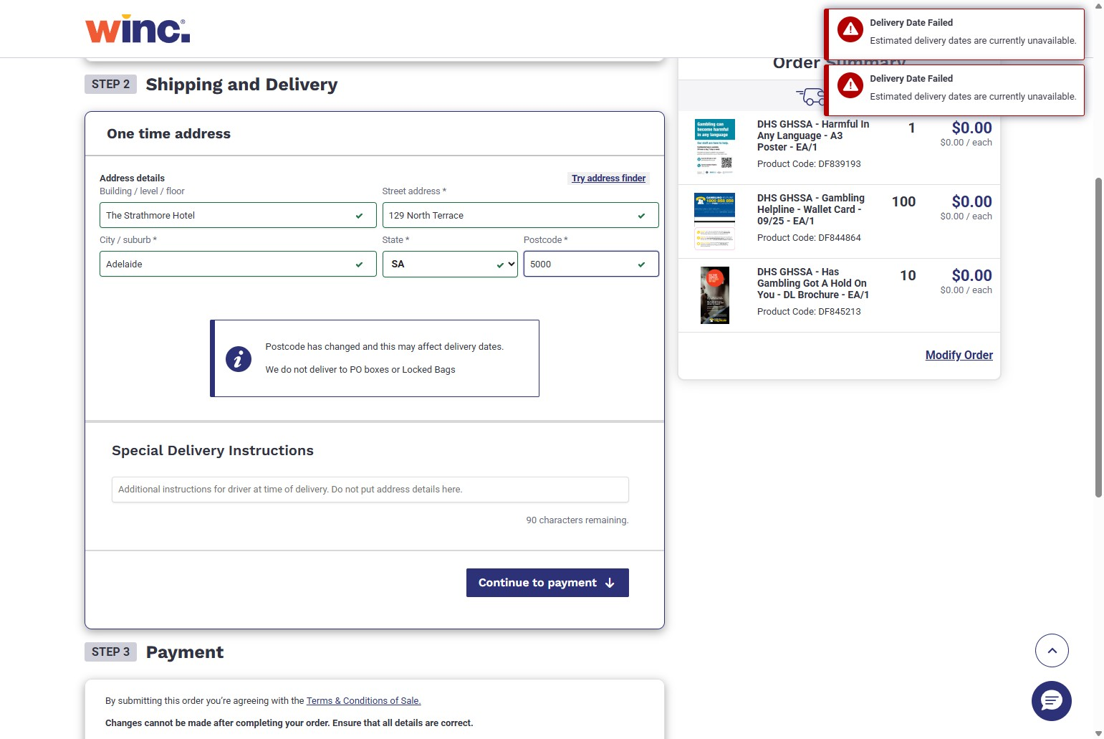

Click "Continue to payment" to proceed.
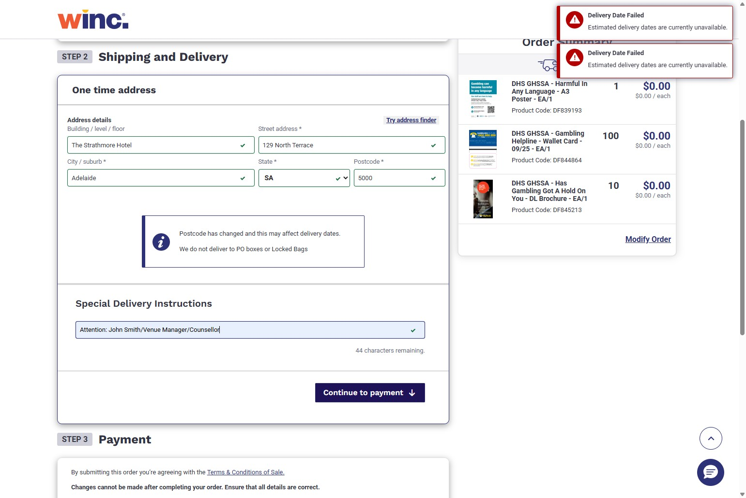

Step 3: Payment. Please ensure you keep the payment method to 'Charge to Current Account'. Click "Complete order" to finalise your order.
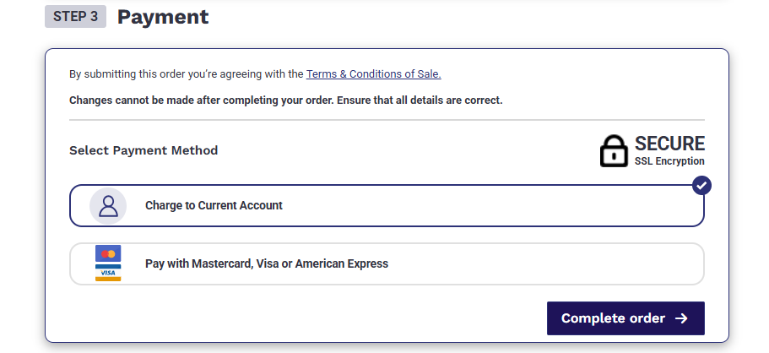

You will then be taken to the order confirmation page
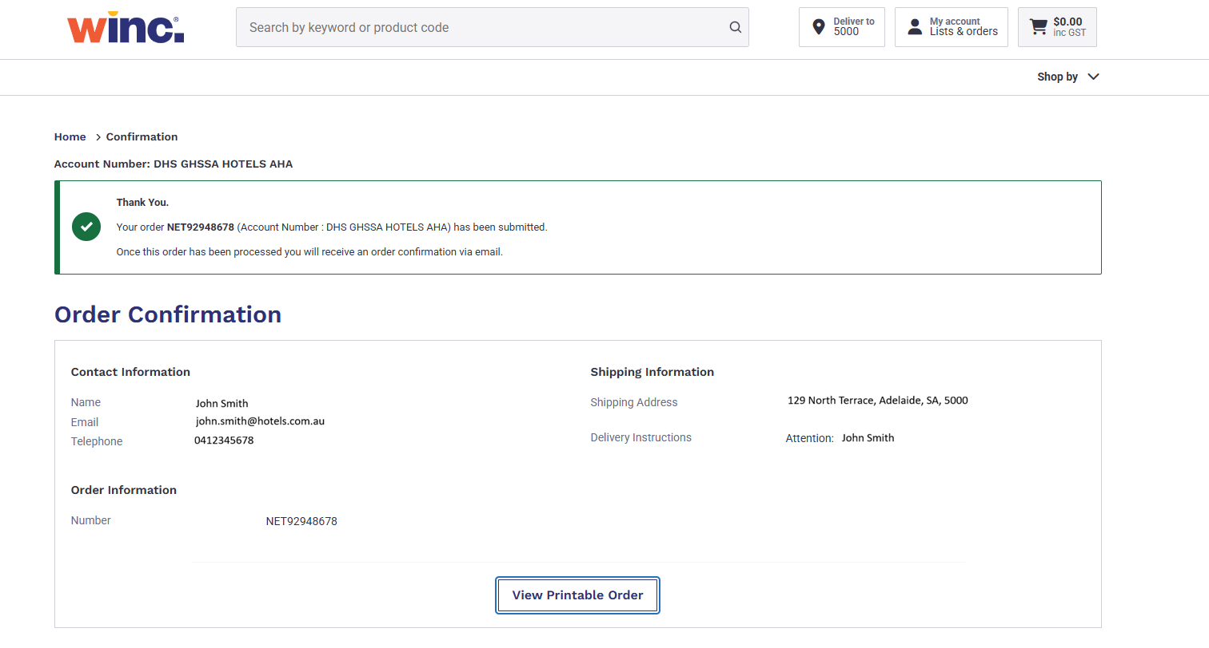

You will also receive a confirmation email. Please keep these emails so you can track your order or for any issues that may arise
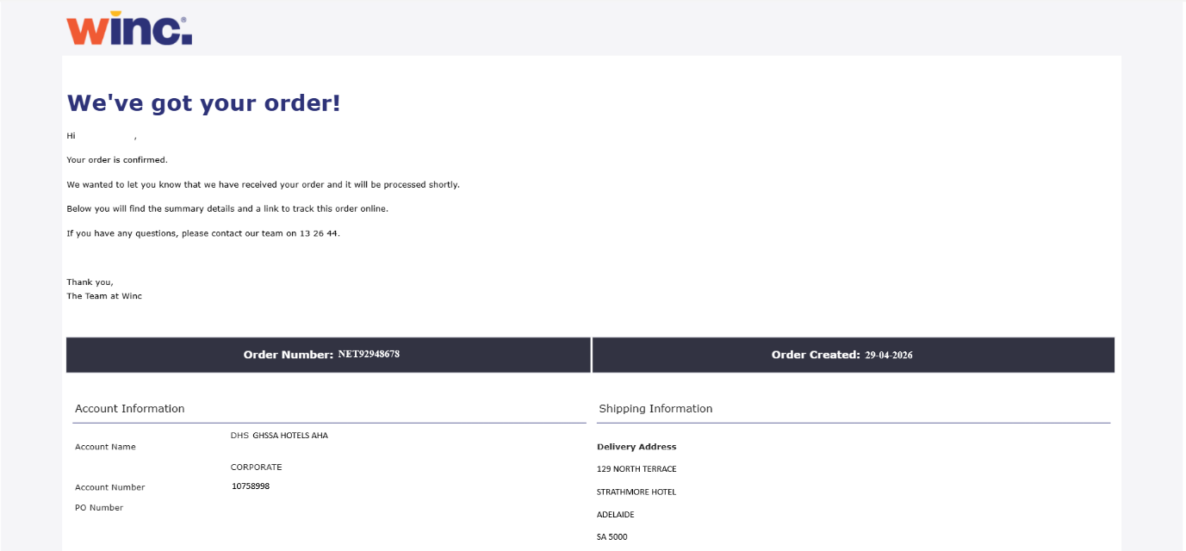

How to track your order
Click "Track Order" from the home page
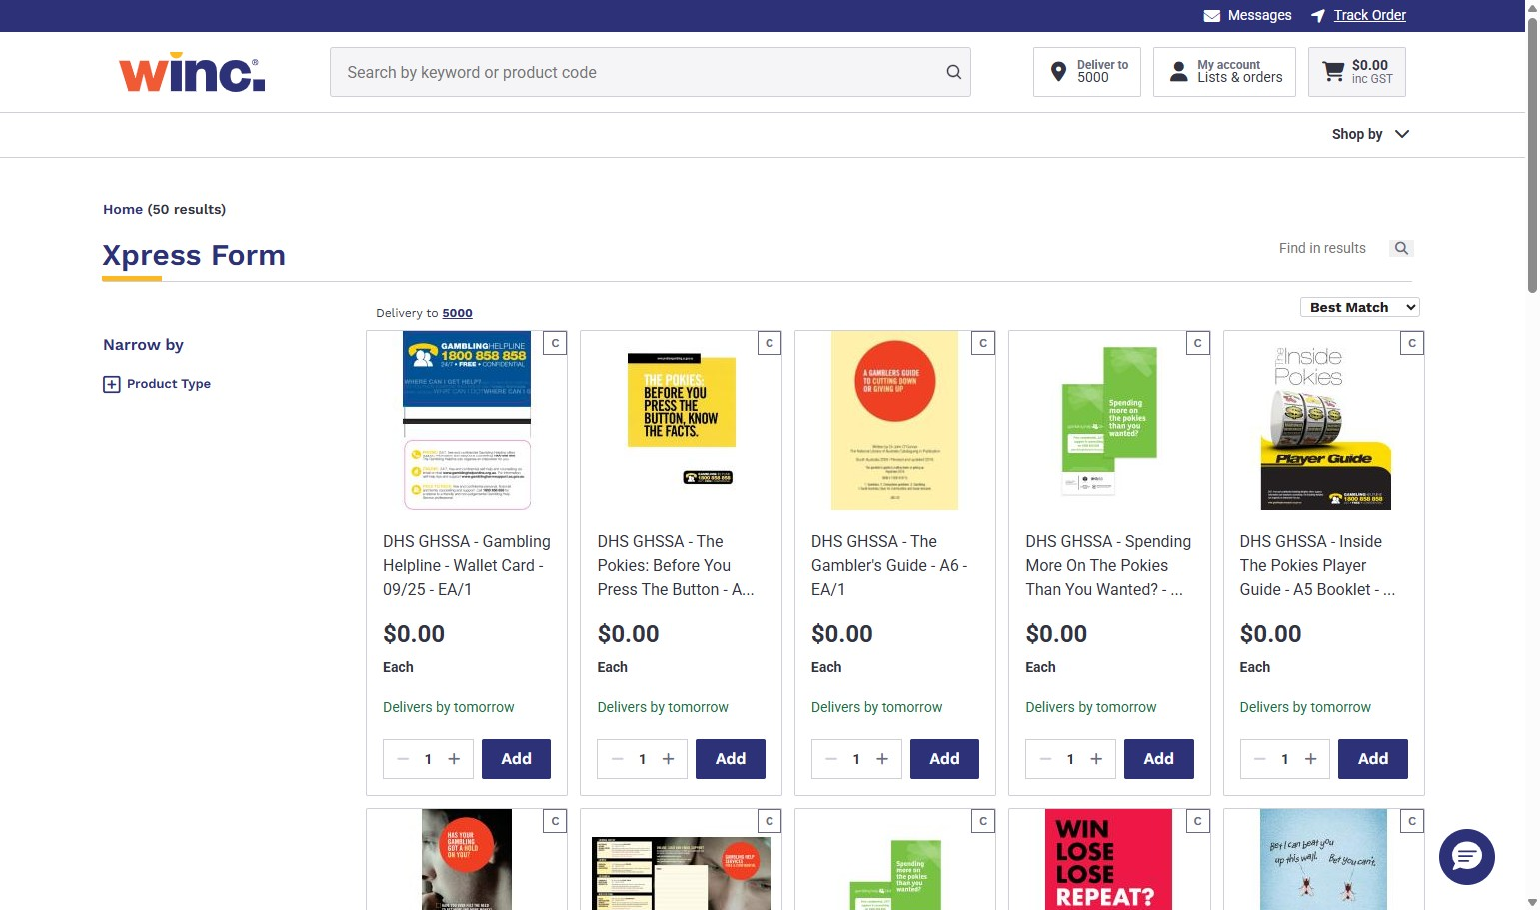

Click the "Enter your Order ID" field and enter your order number
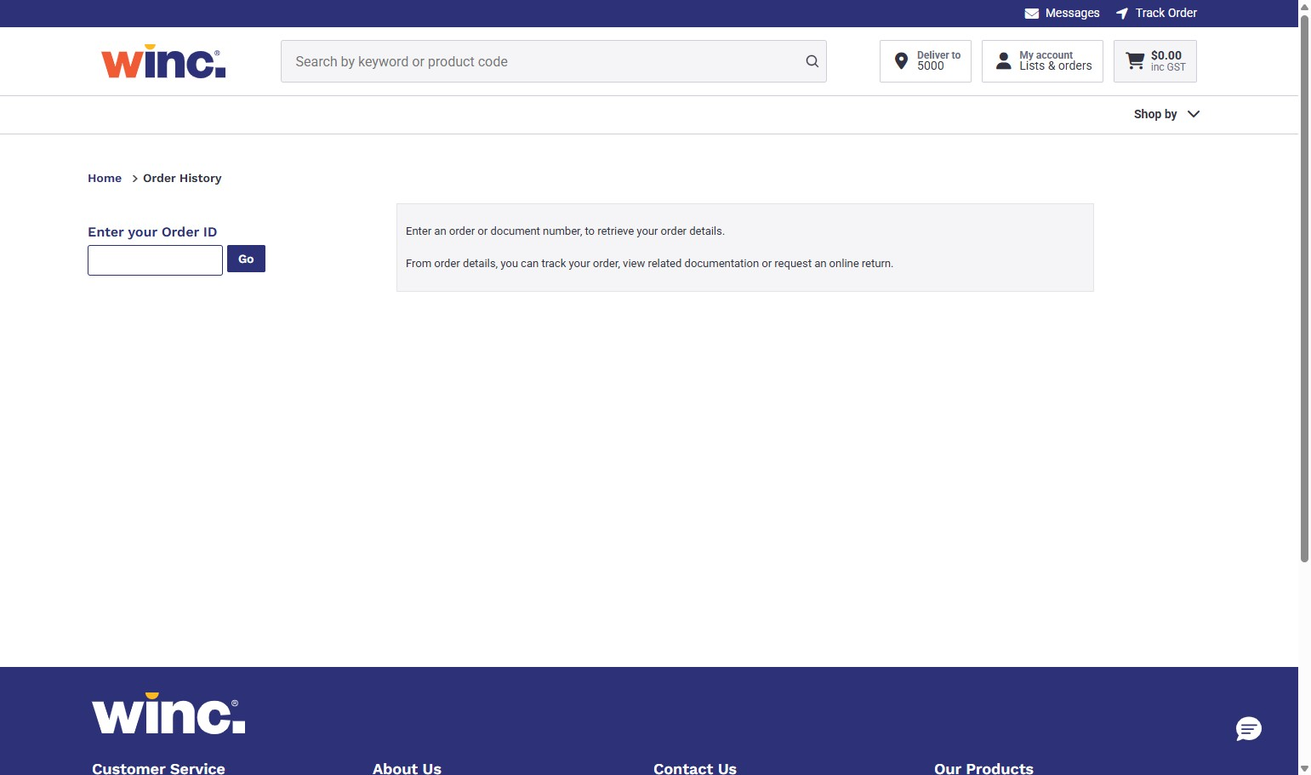

Click "Go"
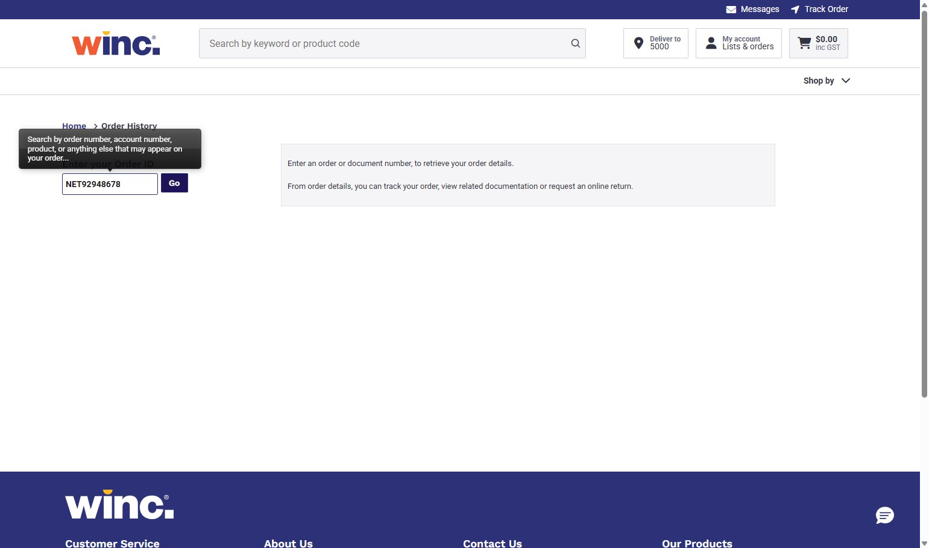

Click “Track Order”
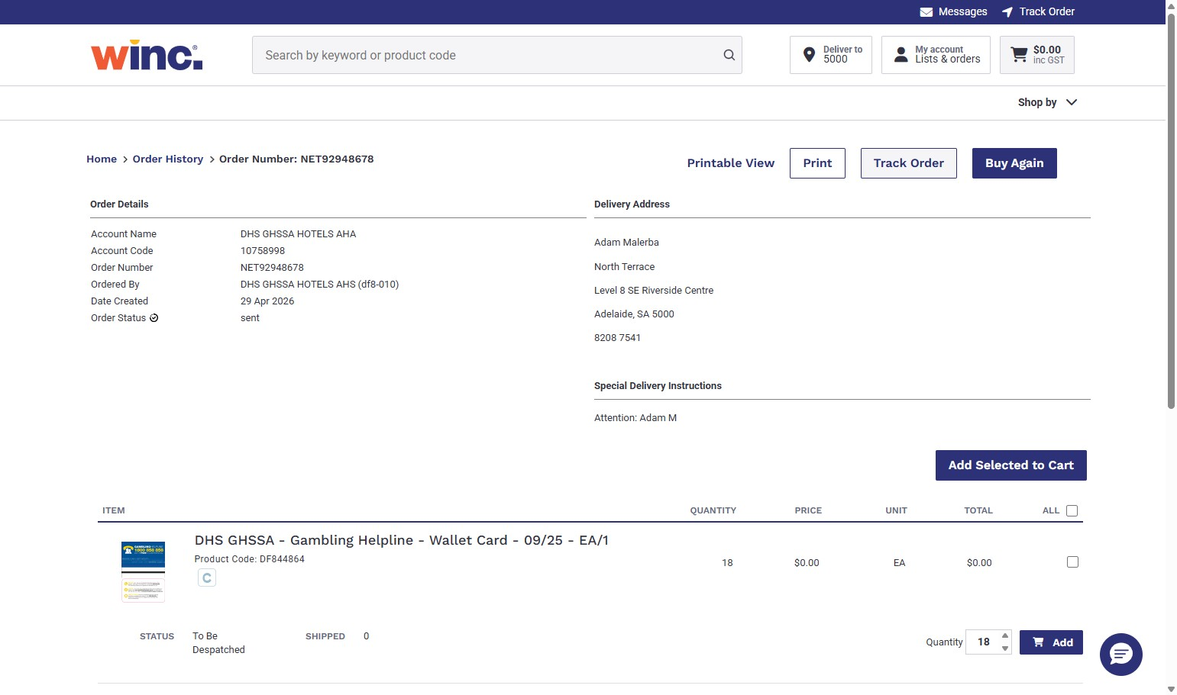

The order status is now visible
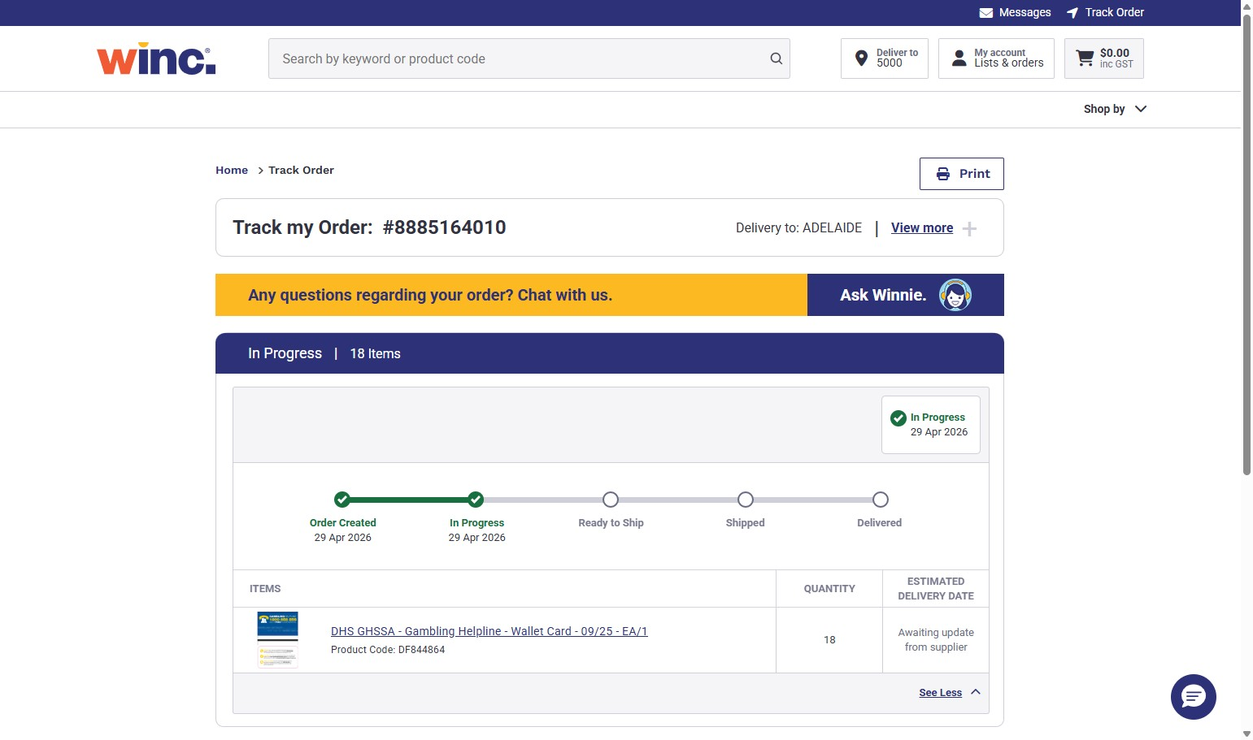

Logging out of the system
Click “My Account”
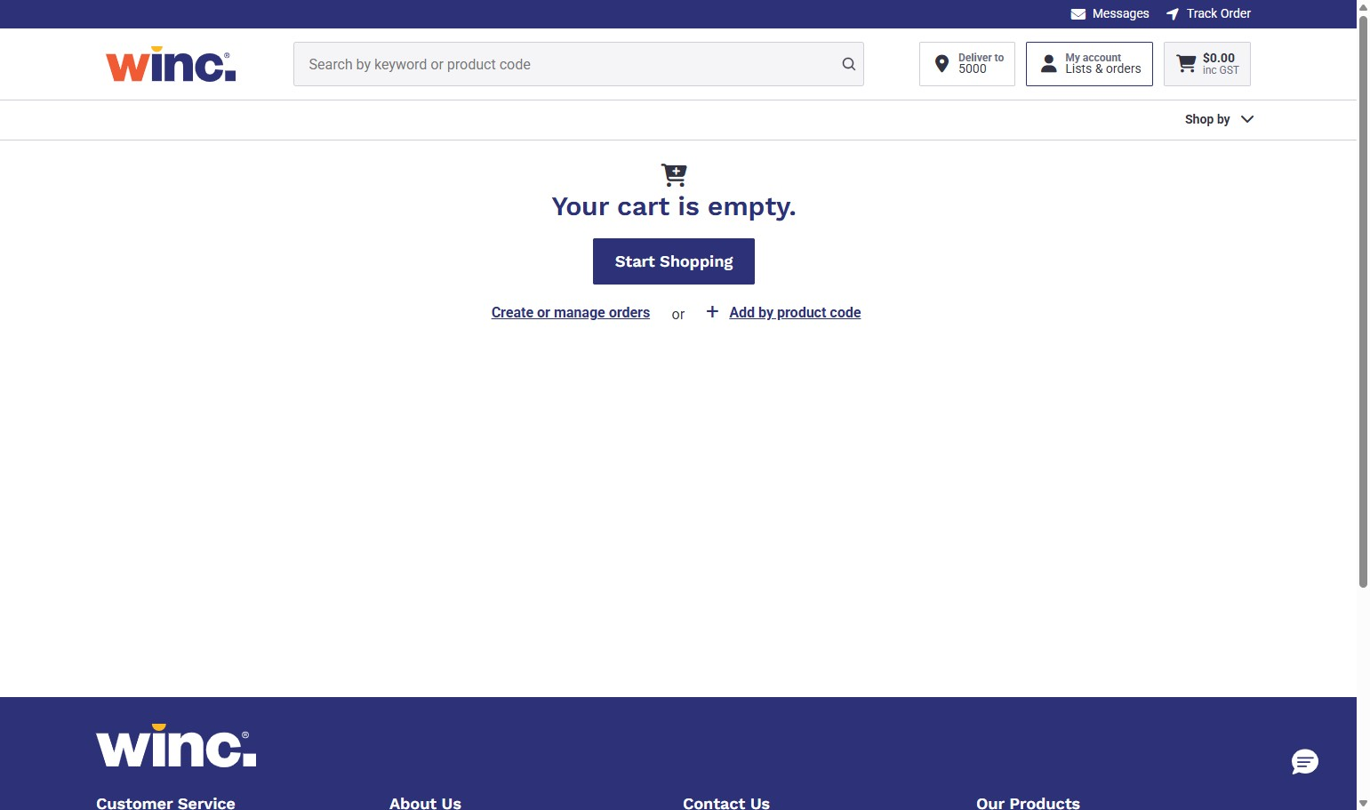

Click “Log Out”
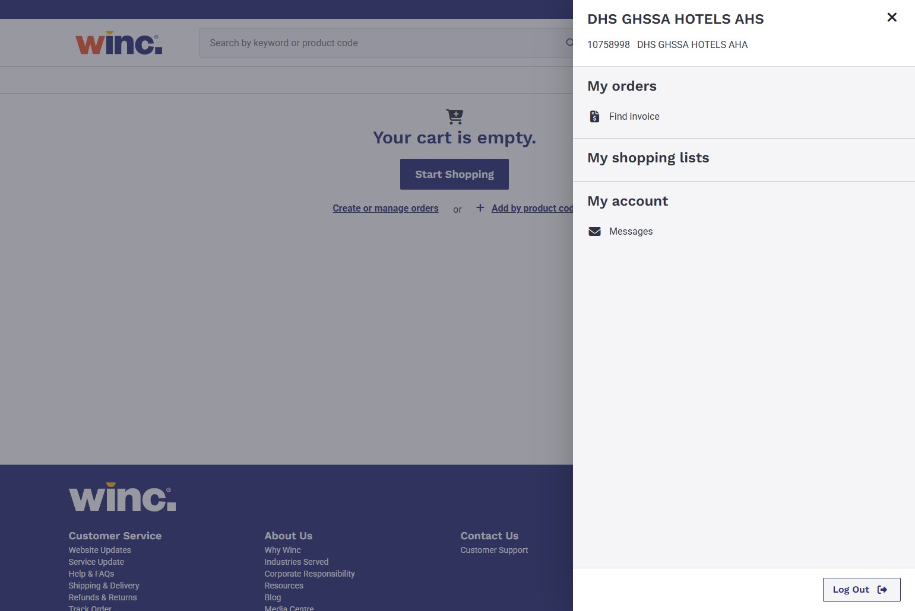

Items not in stock
Alert! Note the “Please call” on an item. This means it is currently not in stock
You can still order items not in stock. These items will be delivered once they are replenished.
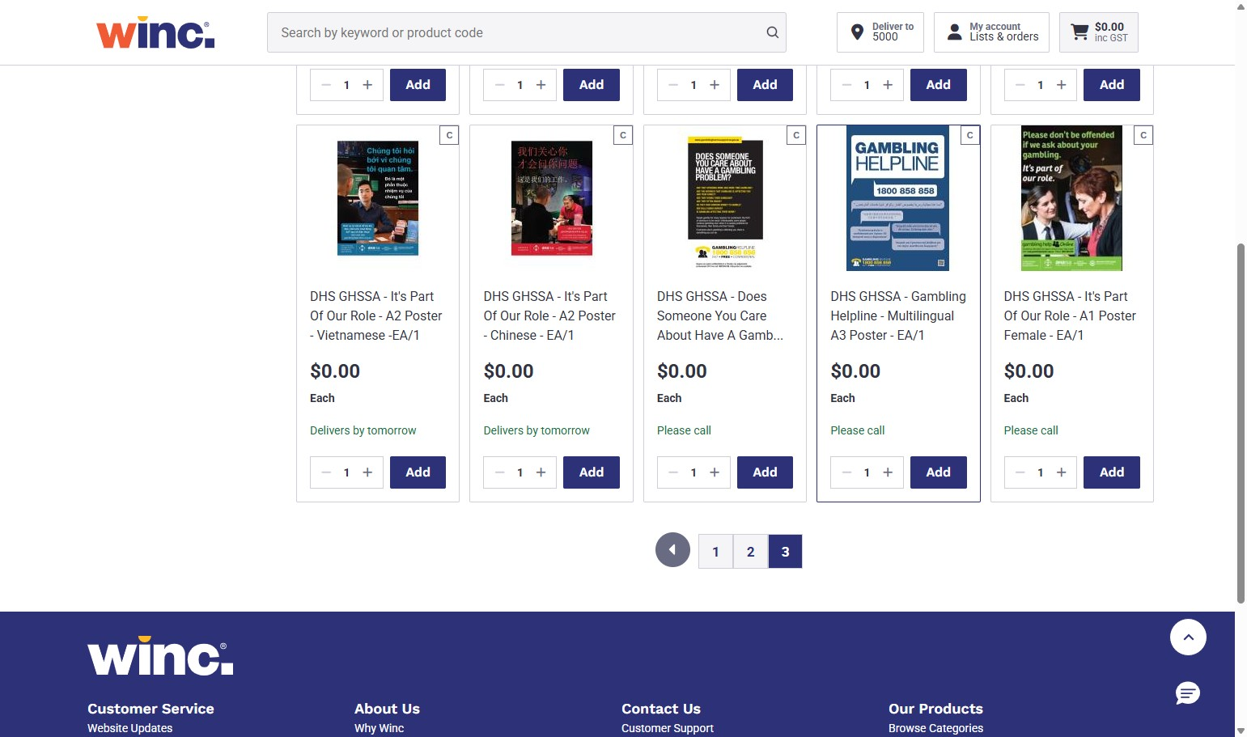

Alert! The missing stock quantity is another way to see that the item is not currently available
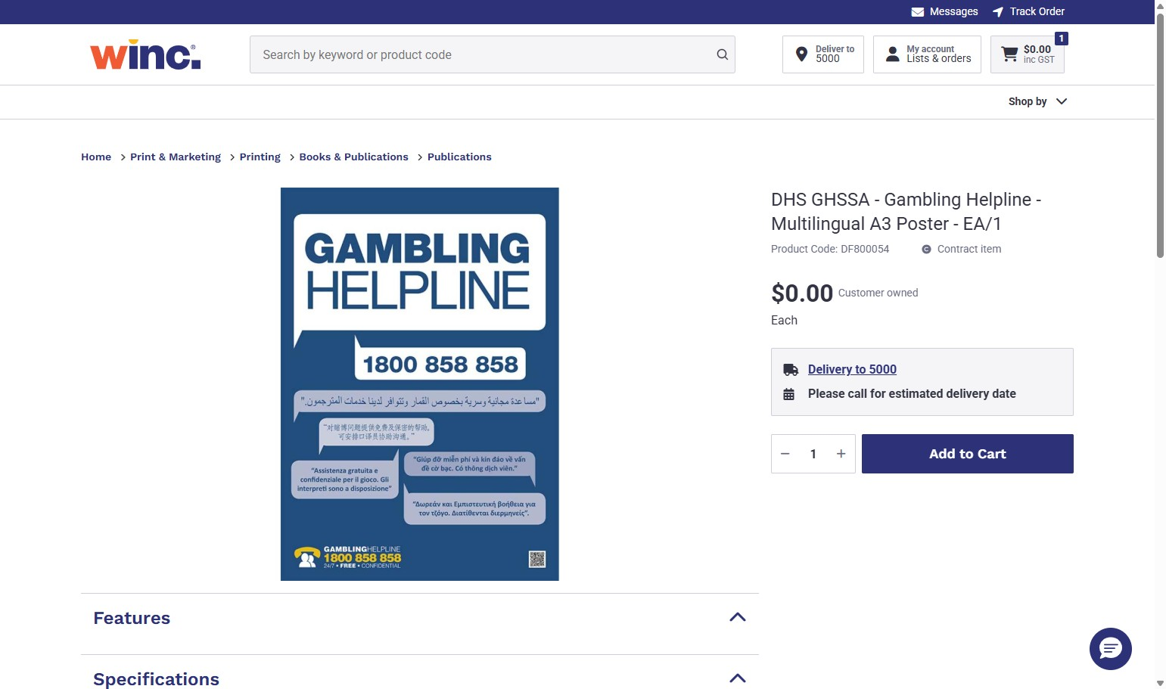
Alert! The missing stock quantity on the item in the cart is the last way to see that it is currently not available
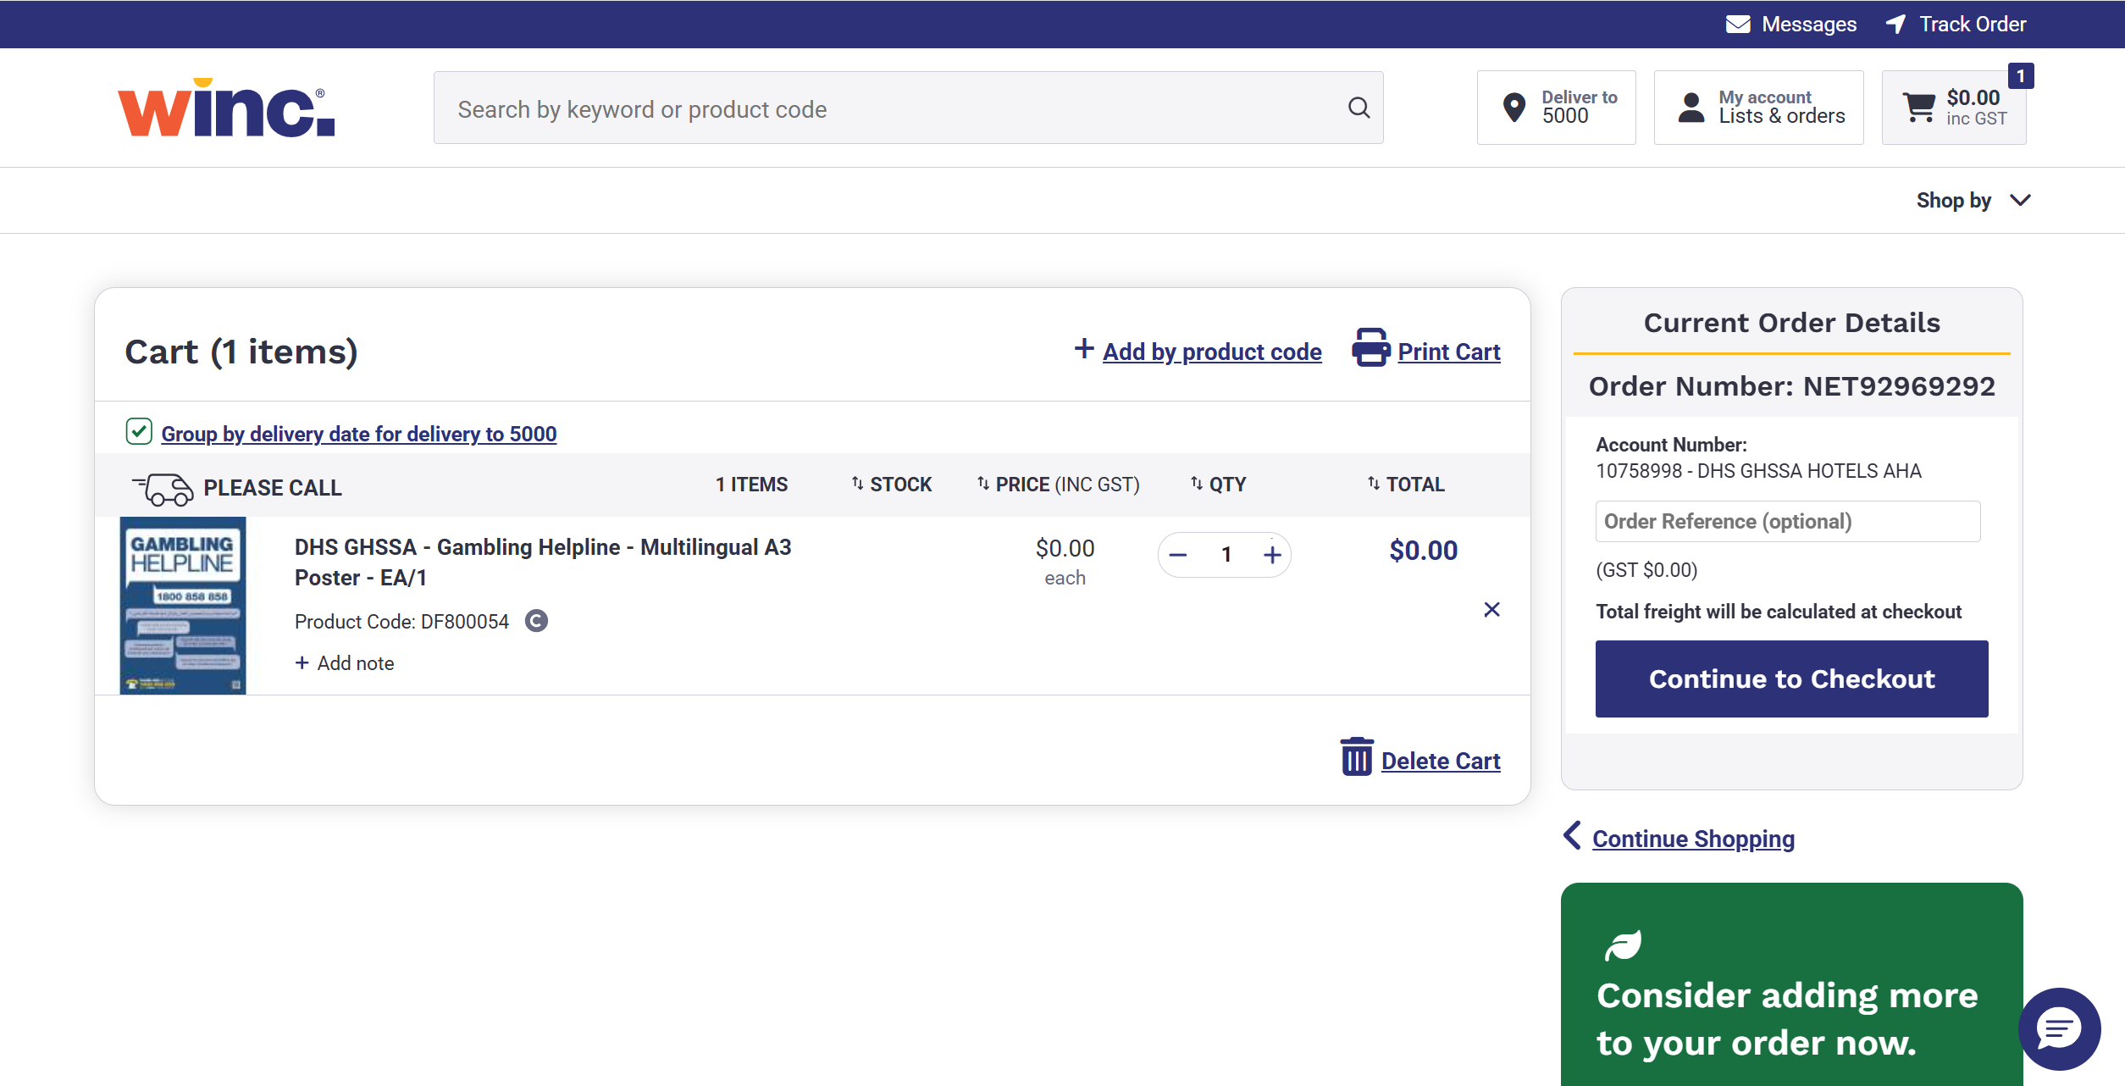

Item stock limit
See below for an example of an order that exceeds the stock limits. You must amend item amounts to the specified allowance to complete your order.
